flat side of cube

1

rounded corner

red vectors: triangle normal vectors

green vectors: smooth normal vecctors

flat side

of cube

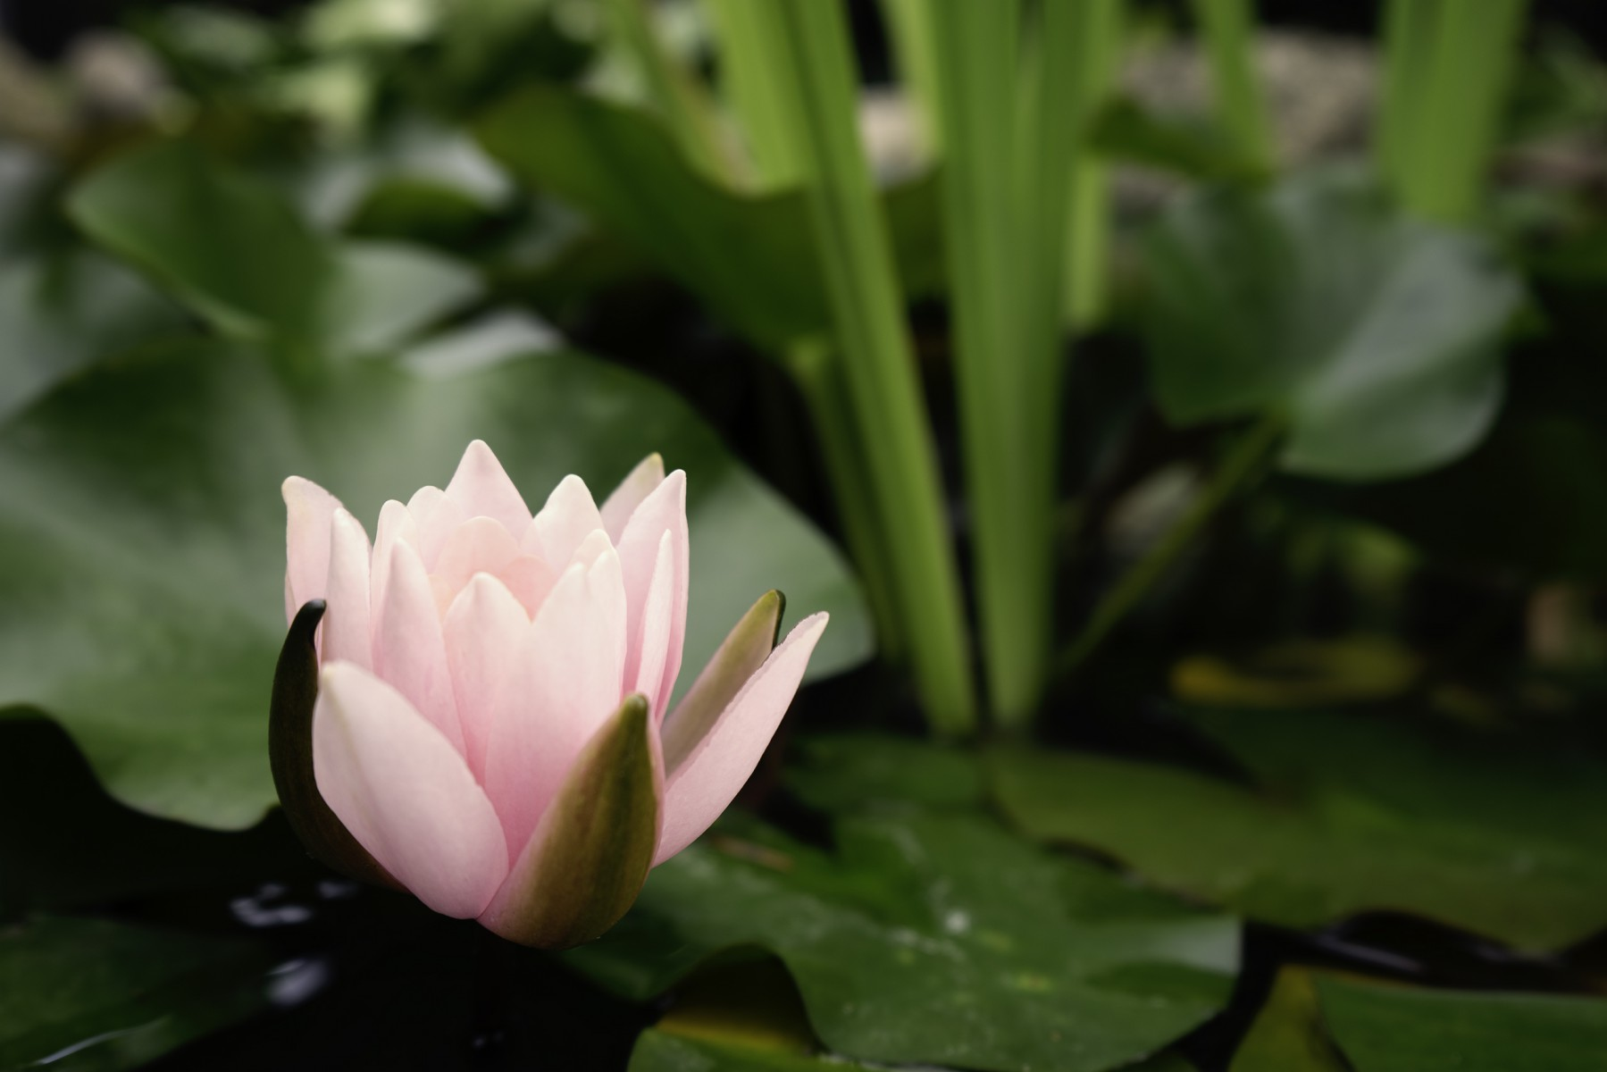

original image



only the flower

with a transparent

background.

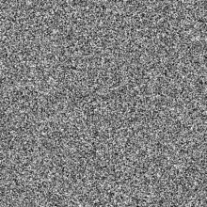

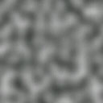

outward bulge

inward bulge